
Australian Academy of Science

Summer Program in Australia – 2007.

30 DAY - RESEARCH REPORT

PART A

Your report will assist the Australian Academy of Science to meet its reporting requirements
to the Commonwealth of Australia. It will also help the Academy in the organisation of future Summer Programs for US graduate students. You are not limited by the space provided below and you can expand any of the items below as you see fit. If you wish to include attachments and/or photos, you are welcome to do so.

- Name, business address and email address:
Gregory Crosswhite
University of Washington
Department of Physics
Box 351560
Seattle WA 98195-1560

gcross@u.washington.edu

- Current status

Master course  Doctor course Postdoctoral researcher
- The title of your research project.
Applying variational techniques to find translationally invariant matrix product representations of ground states for infinite one-dimensional quantum spin systems.

- The name and address of your host(s).

Andrew Doherty
Physics
The University of Queensland
St Lucia, QLD 4072

- What is the primary motive for your participation in the program? (Chose one answer only)

 To gain specific knowledge related to your current research
To work with a particular researcher at a particular lab

To work on a particular research project

To acquire international research experience

To experience life in Australia

- It is expected that your participation in the Summer Program with Australia would enhance your research experience and promote collaborative opportunities.

Please indicate if and how your visit to Australia achieved these outcomes and if there were other immediate benefits of the visit to your personal research work such as papers expected to be published, presentations, etc

My visit to Australia definitely achieved both outcomes.

The group I visited has world-class experts in my field, and I learned a great deal while visiting them. Not only did I pick up new tricks and techniques, but talking with them gave me a better perspective on the state of the field – where it is at, and what kinds of things will be interesting to work next. They gave me ideas for a really interesting project involving building a code based on a new and untried for simulating two-dimensional quantum systems.

Also, it has been really great just to meet and establish contacts with people in the field (i.e., those studying matrix product state techniques). My advisor at UW does not actually do work in this field; he suggested that I do work in it in part to bring expertise back into the group. Thus, this is the first time that I have had really had the opportunity to interact with people working directly on the kinds of things that I am working on.

Finally, the collaborative experience itself has been very helpful to me. I must confess that as a lowly graduate student I had previously felt timid about contacting professors in other schools to ask for advice or exchange ideas. This collaborative experience has made me feel more comfortable doing that kind of thing, which will help me a lot.

I could write a paper on the work I did over the summer, but it was suggested to me by the group that it would be better to wait until I got the sequel project (a two-dimensional system) working and then publish a better paper that discusses both, so this is what I will do. So, in short, this will result in a publication eventually, but probably not an immediate one based only on the work done this summer.
- Were the pre-departure communications useful to you in preparing to participate in the program?

 useful not useful
If you chose 'not useful' please explain.

- Was the information provided at the orientation sufficient?

 sufficient not sufficient
If you chose 'not sufficient' please explain.

- How often did you exchange research options or ideas with Australian researchers other than your host?

daily  often occasionally seldom

- How do you evaluate the degree to which you achieved your research objective?

 beyond expectation fully accomplished satisfactory unsatisfactory
If you chose 'unsatisfactory' please explain.

- What aspects of the program were the most interesting and valuable to you?

Professionally, as I have discussed earlier, the most valuable part of the program was being able to interact with experts in my field in a collaborative setting – both to learn from them, and to build contacts for the future.

Personally, it was really great to experience life in Australia first-hand. Most of my previous exposure to Australia had been through stereotypes, so it was good to see what the country was really like. It is also nice to see your own country from the perspective of another; for example, I never really appreciated how prevalent American culture is in other countries—from McDonalds to pop music. Finally, I have never had the opportunity to do so much travelling before, and it has made me appreciate what I’ve been missing.

- How do you evaluate the overall program?

 excellent good satisfactory unsatisfactory

- Having experienced research and life in Australia, what do you think the possibility is of your conducting future research in Australia?

 Would like to create opportunities

If a favourable opportunity arises

Not interested

- Please add your comments (if any):

We had been told how nice Nancy and Charis were, but it turns out that they were even nicer than we were led to believe! Thank you so much for everything that you have done for us – you really went above and beyond the call of duty to make us feel comfortable in Australia!

30 DAY - RESEARCH REPORT

PART B

Participants name: Gregory Crosswhite

USA University: University of Washington

Australian research advisor(s):

Andrew Doherty

Australian host institution(s):

University of Queensland, St. Lucia

Research subject:

Applying variational techniques to find translationally invariant matrix product representations of ground states for infinite one-dimensional quantum spin systems.

1. Research description:

The laws of quantum mechanics give rise to a strange behaviour called entanglement, in which two or more particles can each seem to know what the others are doing, no matter how far away they are from each other. Imagine for a moment that you and some of your friends had entangled dice. Then no matter where you are, when you roll your die, you will know that all of your friends will get the same result when they roll their own die. This will be true even if, say, one of your friends was on Mars and decided to roll their die at the same time as yours. This is not because the dice are fixed; each time you roll, you get a different and unpredictable result, but that result will always be the same as that obtained by your friends. This effect appears as if it were communication faster than the speed of light, and so Einstein dubbed it “spooky action at a distance.”

Even though entanglement may be spooky, it turns out to be very useful. Although you cannot use it for actual faster-than-light communication, it turns out that if you build a computer that can tap into it – a quantum computer – then you get the power to solve problems efficiently that are intractable for classical computers. Furthermore, it turns out that entanglement is responsible for many exotic behaviours we see in materials, such as superconductivity and superfluidity, that we can and do make use of.

Unfortunately, the presence of entanglement in a system makes it very difficult for it to be simulated. (This is both a blessing and a curse – if all such systems were easy for us to simulate, then a quantum computer would not be able to give us more power than our current computers!) To see why, contrast quantum dice with normal dice. If you had a handful of normal dice, then all you would need to know the probability of each outcome of all dice is just the probability distribution of each individual die separately. However, for quantum dice, due to the presence of entanglement, you cannot do this because the probability distribution of each die can depend on the outcome of rolling the others; instead, you have to determine the probability of each and every one of the outcomes possible for all the dice – 6^{N} outcomes for N dice! This makes it intractable to completely understand the behaviour of even 100 quantum dice.

Fortunately, although in general quantum systems need an exponential amount of information to be simulated properly, in practice many systems of interest can be adequately simulated with much less information. The trick is to restrict yourself to a subset of all possible distributions that gives you enough flexibility to adequately duplicate the behaviours of the system while still being small enough to be tractable. One such subset which was introduced in the mid-90’s is called matrix product states. These can be visualized as diagrams which look like the following:

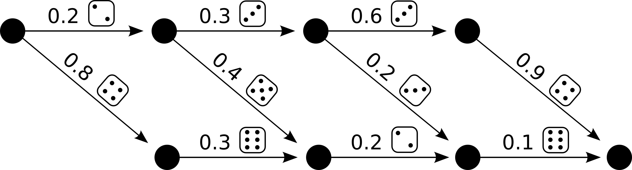

Each possible “walk” through the diagram gives a possible roll of 4 dice, and the probability of obtaining that combination is given by the product of the weights along the path. So for example, the probability of rolling 2, 3, 3, 6 is 0.2 ⋅ 0.3 ⋅ 0.2 ⋅ 0.1 = 0.0012, as illustrated in this diagram:

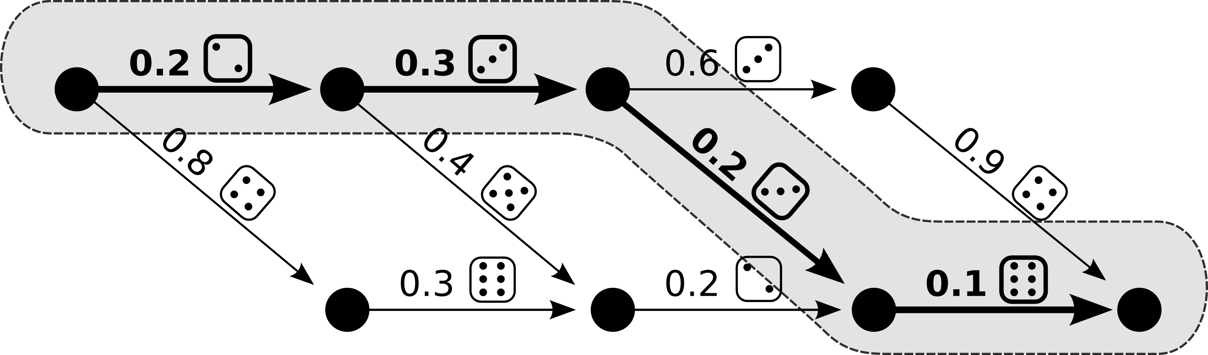

There has been a lot of interest in matrix product states because they seem to offer a good compromise between size and expressive power; the amount of information needed to represent them only grows linearly with the size of the system being modelled, and yet they are able to adequately capture the entanglement present in many systems in which we are interested. However, since they are relatively new, we are still investigating exactly how effective they can be, and there are many situations in which we are still figuring out the best way in which to apply them. This is the basis of my doctoral program research.

2. Research activities:

“If we knew what it was we were doing, it would not be called research, would it?”
- Albert Einstein

During the summer, I designed an algorithm to find translationally invariant matrix product state representations for ground states of infinite one-dimensional systems; an example of what such a representation looks like is as follows:

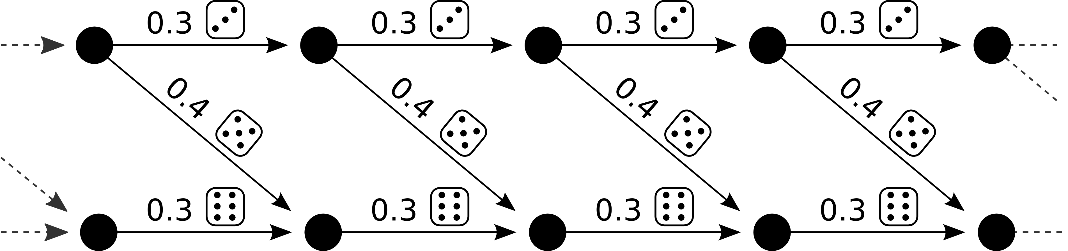

The links (which correspond to the weights of possible outcomes at a site) are repeated ad infinitum; thus, to represent this infinite system we only need the set of links at one site.

There are many reasons why we are interested in finding ground (i.e., lowest energy) states, but one of the major ones is simply that they are the easiest states to find. To find higher energy states one has to solve an eigenvalue problem, which is difficult; by contrast, to find the ground state one only has to solve an optimisation problem, which is much easier. The premise of algorithms based on the optimisation approach is that we find the lowest energy state that can be expressed in matrix product form, and then hope that this is not too far from the true ground state of the system.

Although there is already an algorithm that finds ground states for translationally invariant one-dimensional systems, it uses a technique called imaginary time evolution, and we were interested in whether we could use a direct variational approach instead. The idea behind the direct variational approach is that you fix all of the weights except those at one site, and then find the set of weights at that site which minimizes the energy of the system. In a sense, though, this goes against the spirit of a translationally invariant state – if one only changes the weights at one site, then one has broken the translation invariance. Our original idea for how to solve this was to update all the sites at once with the new weights at the minimized. However, this idea has a fundamental problem: given that the updated weights were selected at that site assuming the old weights were at every other site, it is not necessarily the case that putting the updated weights everywhere will result in a lower energy state than what one had started with. We had ideas for many tricks that might make this approach work anyway, but after a couple of weeks it was obvious that this was not going to work.

Instead, we turned to an alternative approach. We started with a finite system, and then gradually introduced new sites to the middle of the system. The idea is that after a period of time, the new sites would start to feel like they were in an effectively infinite system, since they would be surrounded by many sites to the left and right. After a period of time, hopefully, each new site introduced would start to appear like the last one, at which point we would declare that we have found the translationally invariant representation.

There were many technical issues that we had to resolve to get this to work. One particular problem which thwarted me for a long time was that in one step of the algorithm an arbitrary complex phase was getting introduced into many of the weights; this prevented the algorithm from converging. I spent many days coming up with kludges to work around this, but eventually my host figured out a very simple, elegant solution that caused all of the phases to be completely cancelled.

Eventually, all of the issues were resolved and the algorithm worked just as we hoped it would! At that point, we started looking at ways to make the code implementing the algorithm run faster. The group offered me a great deal of advice that allowed me to improve my running time by an order of magnitude – runs which had taken two hours were reduced to two minutes. We had shown at this point that not only could the variational method be made to work, but it was competitive with the previous approach.

3. Perspective of research after this program:

My ultimate goal in my research is to learn how to model systems with more than one dimension. Before this program, I had been looking into applying known techniques for modelling some finite sized systems. Now, however, I have been given ideas for a more exciting project: developing a new technique for modelling translationally invariant two-dimensional systems, based on ideas from the one-dimensional code.

We spent the last couple of weeks of the summer discussing how we could extend the approach we had used for one dimension into two dimensions. For various reasons, it is much more difficult to see out how to insert a new site into the center of the system when working in two dimensions; but thanks to the experience of the group in working with two-dimensional systems, we were able to figure out a way to do it. Moreover, they taught me a number of tricks they had learned which I will need to get my code working, as well as to make it efficient.

So, in short, this program has given me exposure to new ideas that have lead my research into a new and exciting direction!

4. Australian advisor's remarks:

